Java Architecture
Objectives
- Identify Java Architecture
- Java Program Execution Flow
- Features of Java
- Evolution of Java
- Identify Real World Application
Java Architecture
Java Architecture is the structure that explains how a Java program is developed, compiled, and executed on different operating systems and hardware platforms.
Java follows the principle:
"Write Once, Run Anywhere (WORA)"
This means that a Java program written on one machine can run on any machine that has a Java Runtime Environment (JRE).

Java Program Execution flow

Java Evolution
Java was originally developed by Sun Microsystems to program electronic devices, not for Internet applications. The goal was to create a simple, portable, and platform-independent language that could run on different devices and operating systems.
A team led by James Gosling developed a new language based on the concepts of C++. Initially named Oak, it was later renamed Java. As the Internet grew rapidly, Java's built-in features such as portability, networking, security, and distributed computing made it ideal for web-based applications.
Today, Java is widely used for enterprise applications, web development, Android development, cloud computing, microservices, big data, and financial systems.

Timeline of Java Evolution
Year | Development
1990 | Sun Microsystems started a project for programming electronic devices.
1991 | A new language called Oak was developed based on C++ concepts.
1993 | The World Wide Web (WWW) became popular, increasing the demand for Internet-based applications.
1994 | Sun developed HotJava, a web browser capable of running Java applets.
1995 | Oak was renamed Java and officially launched.
1996 | Java became a widely accepted Object-Oriented Programming (OOP) language.
2006 | Java became open-source under the OpenJDK project.
2010 | Oracle Corporation acquired Sun Microsystems and became the steward of Java.
2014-today | Java evolved with modern features such as Lambda Expressions, Streams, Modules, Records, Pattern Matching, Virtual Threads, and Cloud-Native development support.  30. import React, { useState, useEffect } from 'react'; const Counter = () => { const [count, setCount] = useState(0); useEffect(() => { document.title = `Count: ${count}`; }, [count]); const incrementCount = () => { setCount(count + 1); }; return (  Count: {count}  Increment  ); }; export default Counter; What effect does the useEffect hook have in this component?Attempted1/1  It updates the document title with the current count whenever the component mounts.  It updates the document title with the current count whenever the count state changes.  It increments the count state by 1 every time the component renders.  It increments the count state by 1 every time the Increment button is clicked.

Different Editions of Java
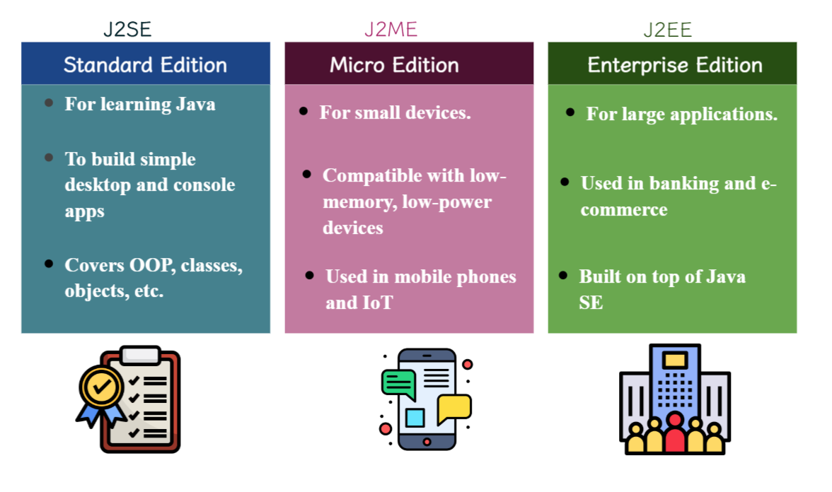

Applications of Java
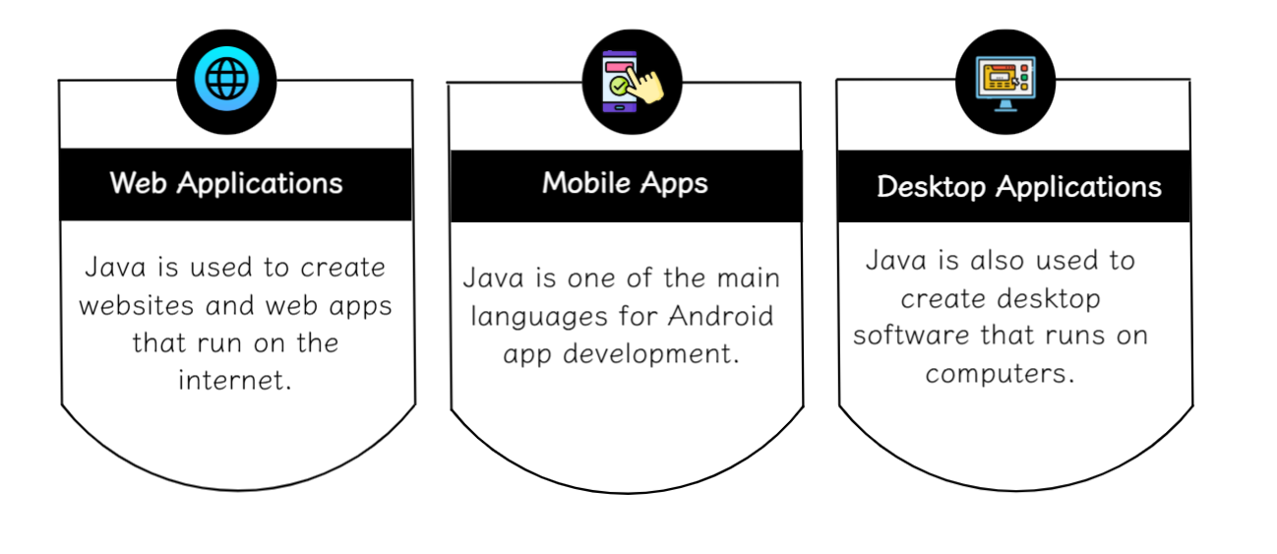

Comparison of Java with Other Languages like C++ & Python
